Waterfall method

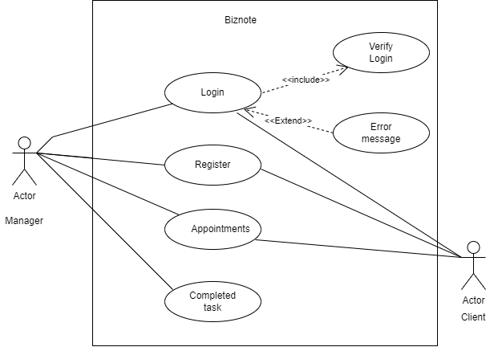

**Context model:** This model shows how systems being modeled is placed in an environment with other system.

It involves working with the system stakeholders to decide wat the functionality should be included in the system.

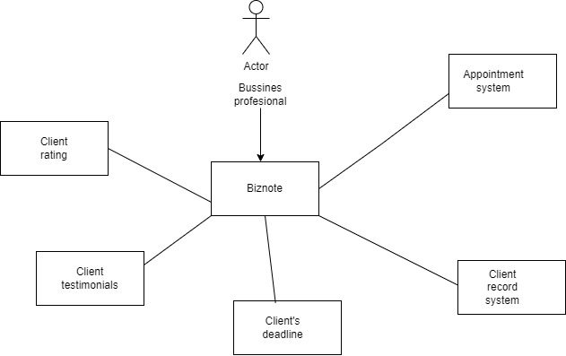

In this context model, Business professional is an external actor. The business professional interacts with the system by recording client services and completing daily tasks, as described. The diagram provides high level view system and it’s external interactions, helping to define the scope of the system and its relationship with external entities.

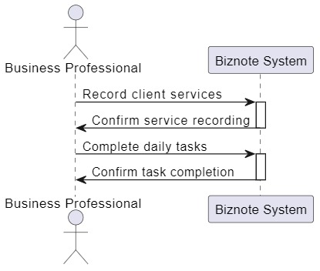

**Interaction model** :The interaction model focus on the behaviour and communication of the system rather than the internal implementation.

This interaction model shows how “Business professional” actor and the “Biznote system “

“Business professonal ” recording client service, which is then confirmed by the “Biznote system”. Next

the “Business Professional” completes daily tasks which is also confirmed by the system.

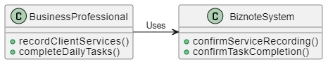

**Structural Model:** “Business professional” class has two metods 1:record client services ,2: complete daily tasks which represent key functionalities which biznote system can perform

“Biznote system” class has two metods 1: confirm service recording and 2 confirm task completion

The arrow between them indicates business professional class is dependent on the biznote dydtem class for functionalities.

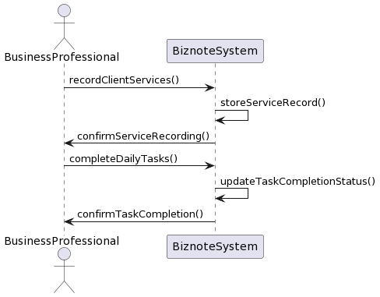

**Behavioral model**